**Pattern Sense: Classifying Fabric Patterns Using Deep Learning**

**Project Documentation format**

**1. Introduction**

**Project Title: [Pattern Sense: Classifying Fabric Patterns Using Deep Learning]**

* **Team Members:**

1. Vusugari Chakradhar[22HM1A05E1]
2. Seelam Govardhan[22HM1A05A8]
3. Shaik Sardar Hussain[22HM1A05D2]
4. Talari Pallavi[22HM1A05D2]

**2. Project Overview**

**Purpose:**

* The purpose of "PATTERN SENSE: CLASSIFYING FABRIC PATTERNS USING DEEP LEARNING" is to develop a system that automatically identifies and categorizes different fabric patterns using deep learning techniques. This aims to automate a task that is currently often done manually, improving efficiency and accuracy in the textile industry.
* To automatically recognize and classify different fabric patterns (e.g., plain, satin, twill, stripes, plaids, floral) using deep learning, replacing manual inspection and handcrafted feature extraction with an end-to-end, scalable image analysis approach
* **Goals:**
* The main goal of "Pattern Sense: Classifying Fabric Patterns Using Deep Learning" is to automate the process of classifying fabric patterns, specifically using deep learning techniques to improve accuracy and efficiency compared to traditional manual methods.
* This involves developing a system that can accurately identify and categorize different fabric patterns from images.
* The primary goal is to move away from manual, labor-intensive methods of classifying fabric patterns, which are prone to errors and time-consuming
* Automated classification can significantly speed up the process of identifying and categorizing fabric patterns, leading to increased efficiency in textile production and management.
* **Features:**

**Dataset & Preprocessing**

* High-quality fabric images captured under controlled illumination, using consistent focal length and ISO settings for clarity
* Data augmentation to create robust variance: flips, rotations (e.g., every 30°), zoom, shear, brightness changes — boosting generalization and avoiding overfitting

**CNN Architectures & Transfer Learning**

* Pre-trained models like ResNet‑50, VGG‑16/19, Google Net/Inception are fine-tuned for fabric textures — combining strong feature abstraction with task adaptation.
* Architecture improvements include identity shortcuts (ResNet) to combat vanishing gradients, small-kernel stacks (VGG), and inception modules for multi-scale feature capture

**Texture-Specific Feature Enhancements**

* Feature fusion: Combine CNN features with classical descriptors like HOG, HSV histograms, LBP, and GLCM to enrich shape and color cues
* Attention-enhanced networks such as DenseNet variants emphasize discriminative texture regions, boosting accuracy

**Scalability & Efficiency**

* Integration of depth wise-separable convolutions (e.g., Mobile Net-style) and channel pruning for lightweight and fast inference—vital for deployment on embedded devices
* Optional ensemble or segmentation heads for defect detection, allowing multi-task operation in production

**3. Architecture**

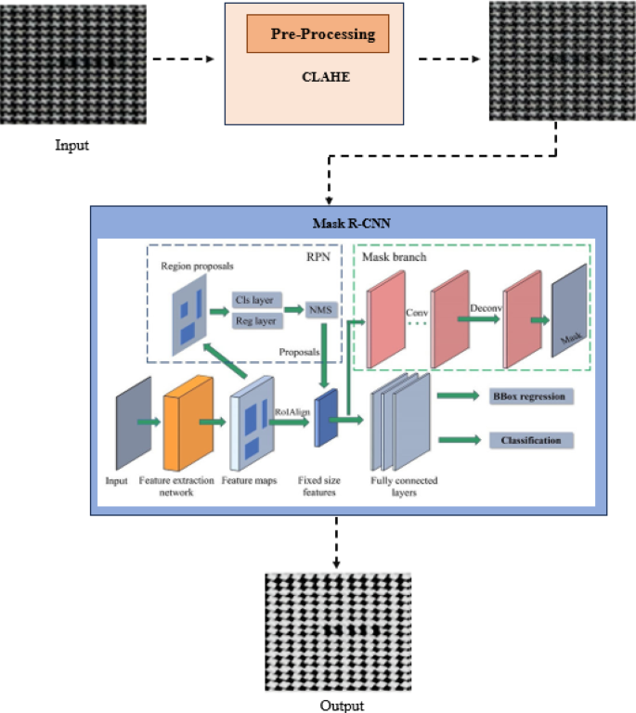

**4. Setup Instructions**

* **Prerequisites**:

To complete this project, you must require the following software and packages.

* Software Requirements:
  1. Visual Studio Code (VS Code) or any Python-supported IDE
  2. Python 3.10 for better suitable to all packages
* Python packages:
  1. Open VS code terminal prompt etc.,
  2. Type “pip install NumPy” and click enter.
  3. Type “pip install pandas” and click enter.
  4. Type “pip install scikit-learn” and click enter.
  5. Type “pip install matplotlib” and click enter.
  6. Type “pip install scipy” and click enter.
  7. Type “pip install seaborn” and click enter.
  8. Type “pip install tenser flow” and click enter.
  9. Type “pip install Flask” and click enter

1. **Installation:**
2. Install Required Packages:

Ensure you run:

pip install flask==2.3.3

pip install torch==2.2.2

pip install torchvision==0.17.2

pip install numpy=1.26.4

pip install pillow==10.3.0

pip install opencv-python=4.9.0.80

pip install scikit-learn==1.4.2

pip install matplotlib==3.8.4

1. Download Dataset:

<https://www.kaggle.com/datasets/nguyngiabol/dress-pattern-dataset>

1. Prepare the Dataset:

python data_preparation.py

1. Create Data Label

python create_data_labels.py

1. Train the Model:

python train_a_model.py

1. Run the Flask Web Application:

python app.py

1. Access the Application:

Open your browser and visit: [[http://127.0.0.1:5000](http://127.0.0.1:5000/)]

**5. Folder Structure**

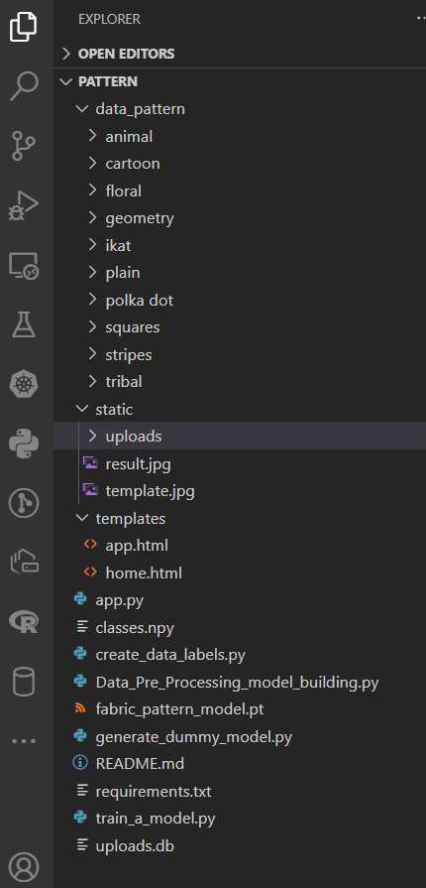

**6. Running the Application**

1. Run the Flask Web Application:

python app.py

1. Access the Application:

Open your browser and visit: [[http://127.0.0.1:5000](http://127.0.0.1:5000/)]

**7. API Documentation**

1. **Home Page**

* **URL:** /
* **Method:** GET
* **Description:** Displays the landing page of the application.
* **Response:** Returns the index.html template.

1. **About Page**

* **URL:** /about
* **Method:** GET
* **Description:** Displays information about the project.
* **Response:** Returns the about.html template.

1. **Inspect Page (Upload & Predict UI)**

* **URL:** /inspect
* **Method:** GET
* **Description:** Displays the image upload form for prediction.
* **Response:** Returns the inspect.html template.

1. **Image Prediction API**

* **URL:** /predict
* **Method:** POST
* **Description:** Accepts an image file, performs classification using the trained model, and returns the prediction.

**Request Parameters:**

|  |  |  |
| --- | --- | --- |
| **Name** | **Type** | **Description** |
| image | File | The image file to be uploaded (JPG, PNG, etc.). |

Upon successful prediction, the following details are displayed:

* Uploaded image preview
* Predicted class label (e.g., "tribal")
* Confidence score (percentage)

**Future Scope for Authentication (Optional Enhancements):**

**Hybrid AI Models & Explainability**

* Physics-informed and hybrid models: Combining CNNs with physics-based models (e.g., fabric drape, fibre structure) can improve authentication robustness and interpretability
* Explainable AI (XAI): Especially for high-value fabrics (e.g., silk, Pashmina), systems that clearly show “why” a pattern is flagged as fake—based on thread density, weave irregularities—will foster trust.

**Enhanced Data & Real-Time Vision**

* High-resolution imaging improvements: Adoption of line-scan cameras, multi-spectral/hyperspectral imaging, and 3D capture can uncover authenticity features invisible to the naked eye.
* Real-time authentication during production: Inline visual inspection can identify anomalies on the fly—enhancing QC and reducing waste

**Generative AI & Pattern Design**

* GAN-based counterfeit detection: As counterfeiters use generative AI to create near-perfect fake patterns, authentication systems will need GAN-based “tampering detectors” to spot synthetic sequences
* Adaptive, co-created patterns: Counterparts could include AI-based modules that generate unique, traceable pattern IDs for each production batch, simplifying downstream verification.

**Sustainability & Circular Fashion**

* Automated sorting for recycling: AI systems will classify fabric prints and materials for optimal recycling—for instance, segregating cotton vs polyester blends for better reuse streams
* Waste reduction & traceability: Authentication tied to lifecycle metadata (e.g., recycled content, eco-certifications) supports sustainable sourcing claims

**Recommended Future Features:**

* Admin Login: Only authorized personnel can retrain or upload new datasets.
* User Dashboard: Registered users can track prediction history.
* API Access Tokens: Protect REST APIs for mobile or external application integration.

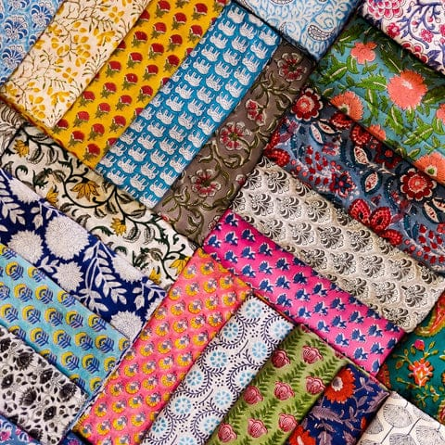**9. User Interface**

**10. Testing**

**Testing Strategy**

**Dataset Preparation & Splitting**

* High-quality, balanced dataset: Collect diverse, high-res fabric images across all pattern classes. Remove duplicates, fill missing labels, and balance classes via augmentation or sampling
* Split into train/validation/test:
  + Common split: 60–70% train, 15–20% validation, 15–20% test.
  + Use stratified sampling to preserve class distributions.

**Cross-Validation for Robustness**

* Stratified k‑fold (e.g. k = 5 or 10) during training/validation. Ensures each fold well represents pattern categories
* Evaluate model consistently across folds—use mean performance and standard deviation to detect variability

**Data Augmentation & Test-Time Augmentation**

* Train-time augmentation: Apply flips, rotations, scale, crop, brightness, shearing, translation, noise—key for texture generalization
* Test-time augmentation (TTA): Average predictions over multiple augmented crops/scales to improve stability

**Evaluation Metrics & Error Analysis**

* Use multiple metrics: accuracy, precision, recall, F1‑score, ROC–AUC to address class imbalance
* Employ confusion matrices to check misclassification patterns and identify confusing fabric classes.
* Conduct error-slice analysis: evaluate performance across image conditions like lighting, fabric type, camera resolution

**Preventing Overfitting**

* Use early stopping based on validation loss or accuracy
* Apply regularization: L2 weight decay, dropout layers.
* Monitor both train and validation performance to detect divergence or overfitting.

**Robustness & Bias Testing**

* Stress-test with perturbed inputs (e.g., noise, lighting variations) to gauge stability .
* Evaluate on different subgroups (e.g., handloom vs machine-made, varying capture devices) to identify biases
* Optional: adversarial attacks for edge-case analysis

**Final Testing & Generalization**

* After tuning, evaluate on the held-out test set one final time—this is the true measure of generalization
* Ensure test data is not used for hyperparameter tuning—it's only for final assessment

**Continuous Monitoring Post‑Deployment**

* Use a monitoring pipeline (e.g., MLflow, Tensor Board) to track model drift: monitor changes in accuracy, input data distribution, class representation.
* Implement proactive retraining triggers when performance drops below thresholds (e.g., F1 < 90%).

**Tools Used**

* **Python**: Core programming language used for model development and backend logic.
* **PyTorch**: Deep learning framework used to build and train the CNN model for fabric pattern classification.
* **Flask**: Lightweight Python web framework used to build the web application and route user requests.
* **HTML/CSS**: Used for designing the frontend user interface of the web application.
* **SQLite**: Lightweight relational database used to store user information and prediction history.
* **Jinja2**: Templating engine integrated with Flask to dynamically render HTML pages.
* **NumPy**: Used for data handling and loading class label arrays.
* **PIL (Python Imaging Library)**: Used for image processing before passing to the model.
* **TorchVision:  
  A PyTorch library used for image transformations, pre-trained models, and dataset utilities—essential for image preprocessing in the fabric classifier.**
* **Scikit-learn**:  
  Used for evaluating the model with metrics like accuracy, precision, recall, confusion matrix, and classification report.
* **Matplotlib**:  
  A plotting library used to visualize training accuracy/loss graphs and evaluation results for better model understanding.

**11. Screenshots or Demo**

**Screenshots**

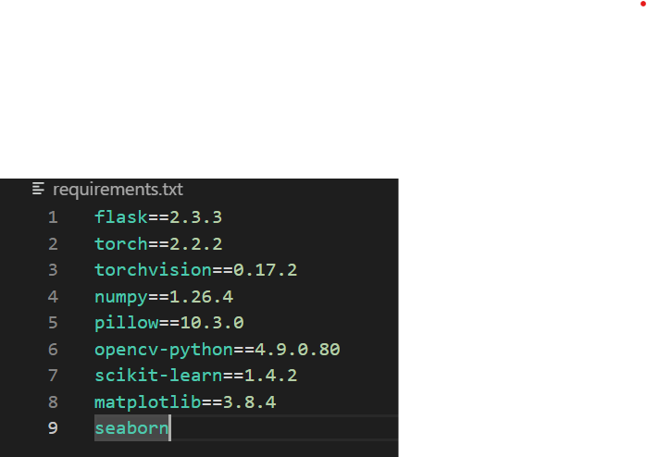The following figure displays the required extensions to run the app successful.

The following is the required structural of the file to be stored.



Open the terminal and type **python app.py** and click on Enter. The IP Address is generated like shown below

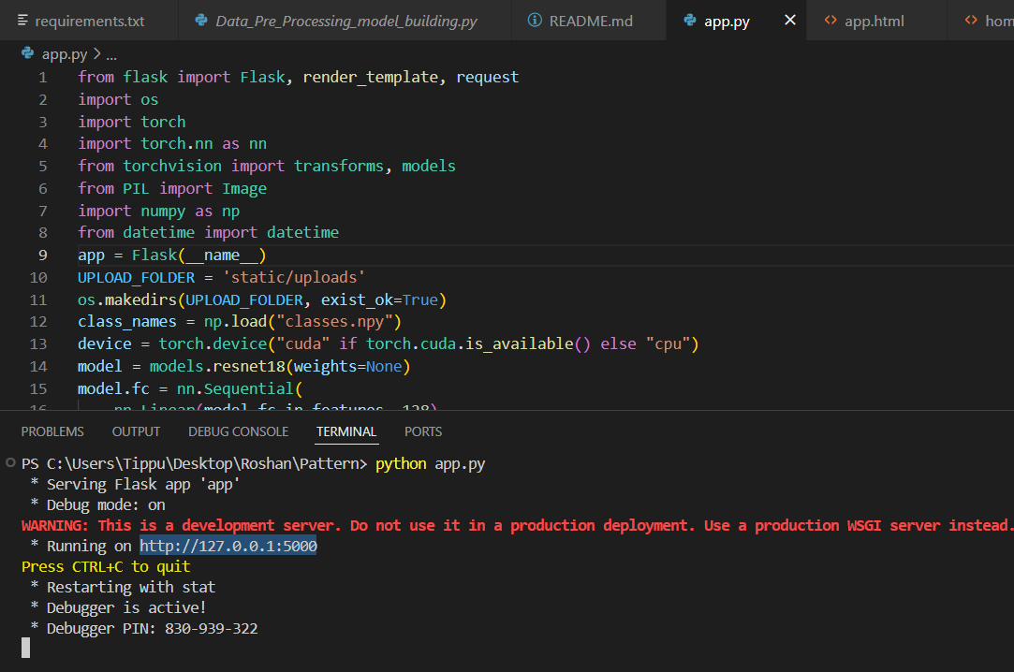

And get copy the IP Address and Paste on the any google page and click enter.

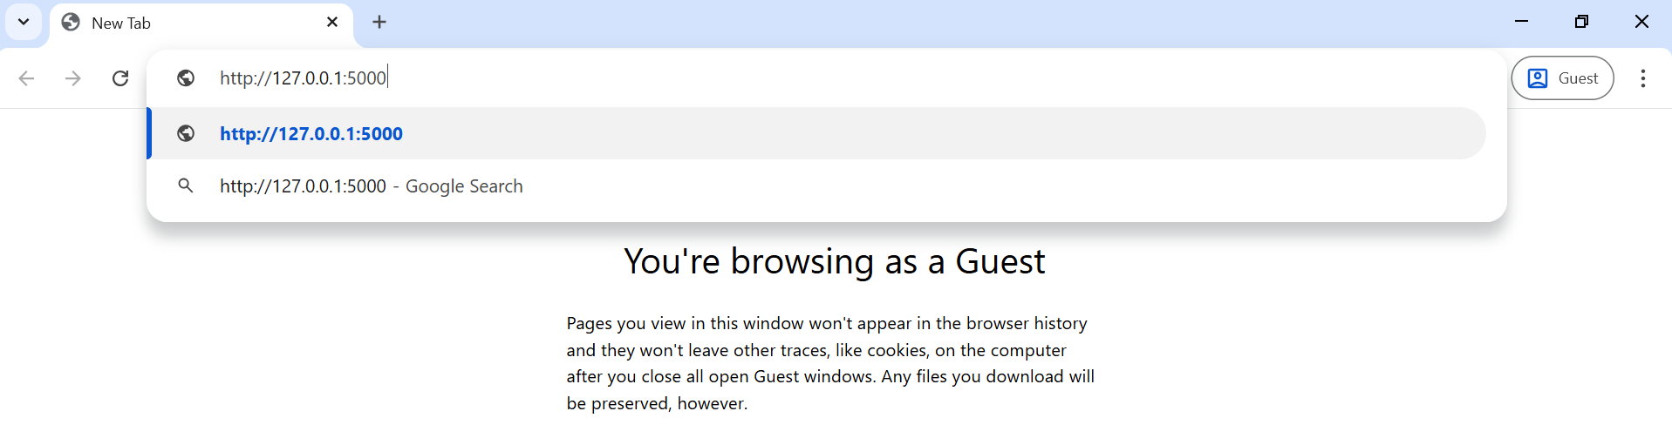

After that you will redirect to the page shown below

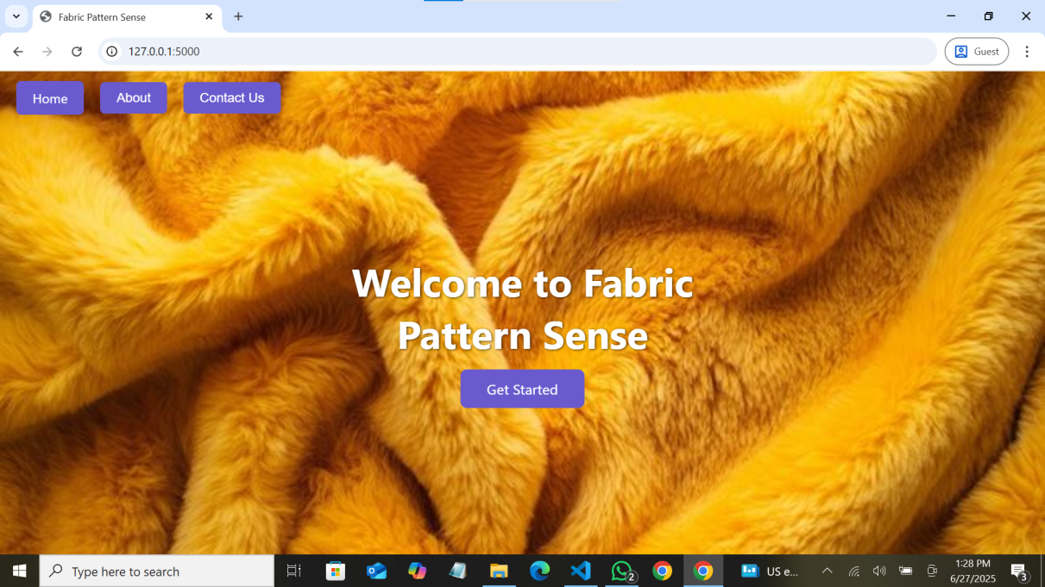

After that click on the Get Started u will redirect to the following page

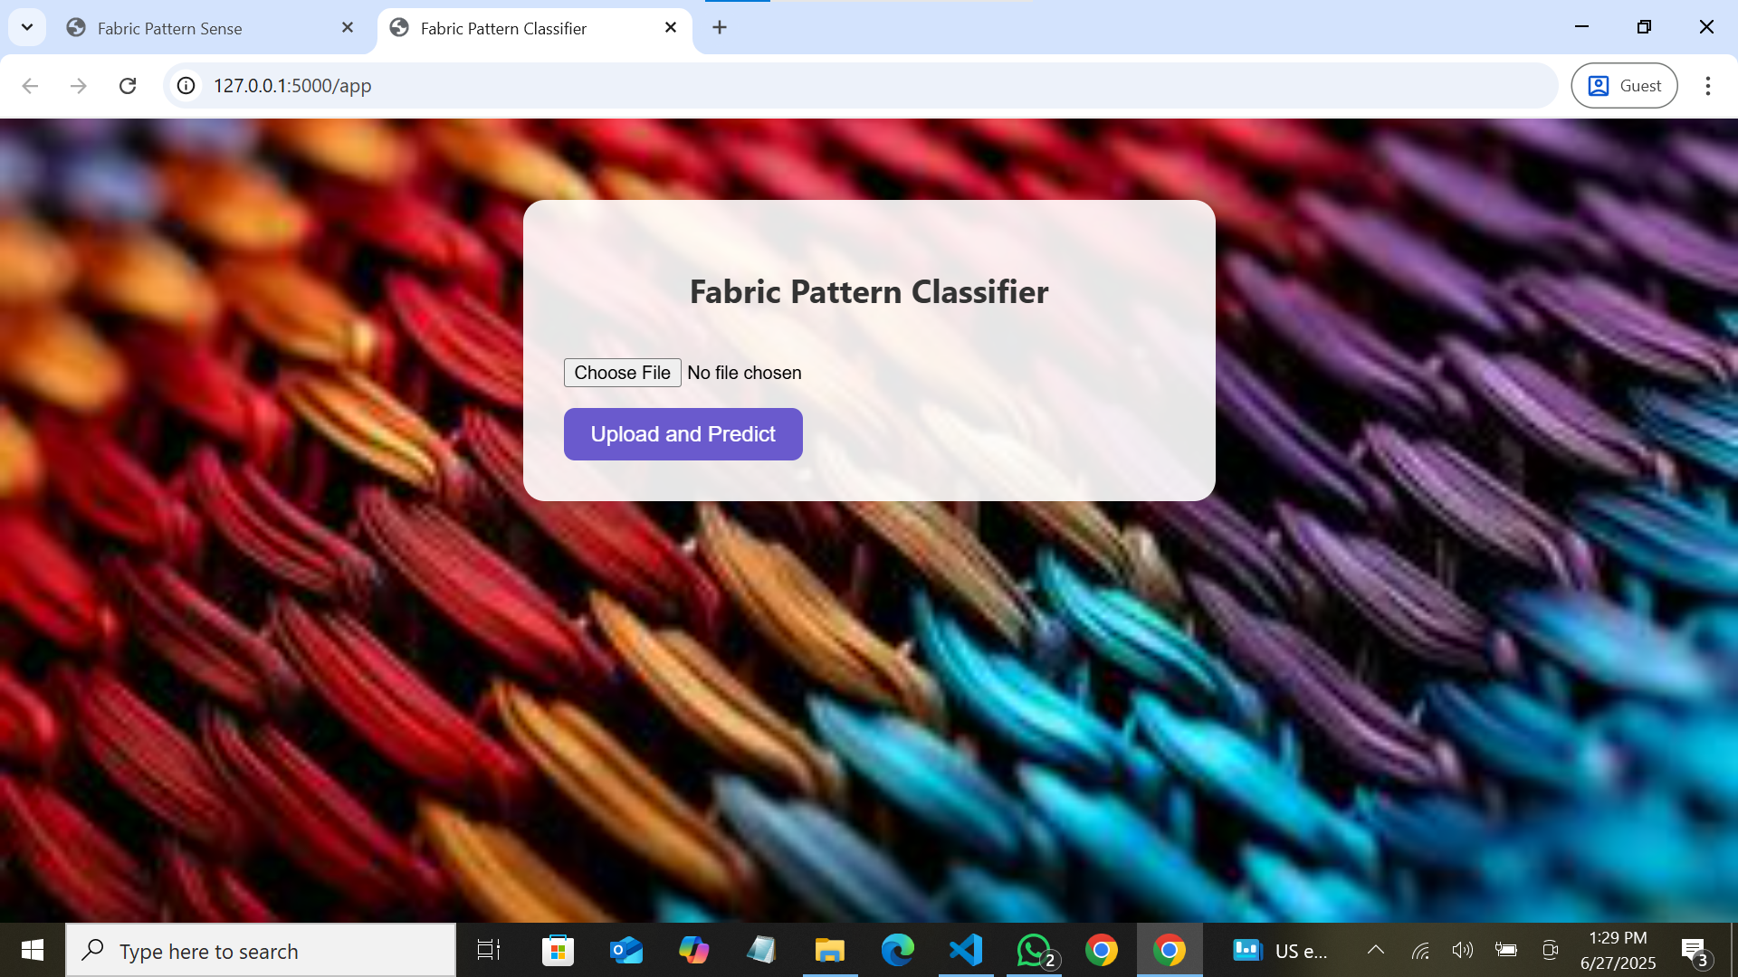

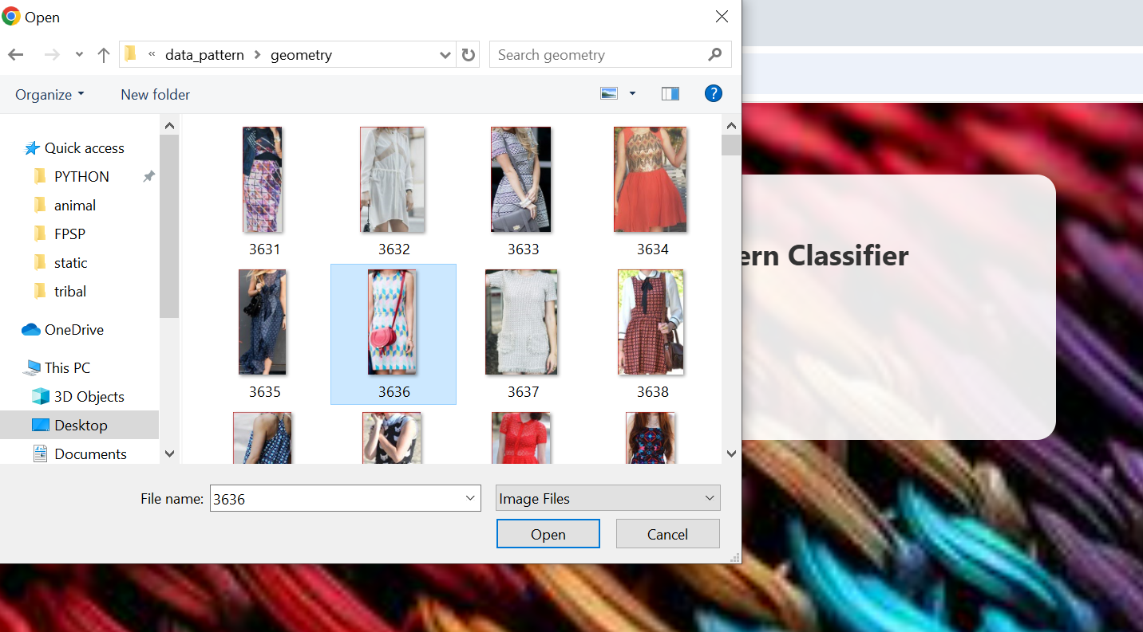Now click on the choose file and select any .jpg or .png file from your files like the below figure

**Project Demo Link:**

**https://photos.app.goo.gl/p2hvXAziVYtauFhP9**

**12. Known Issues**

**Limited & Biased Datasets**

* Small dataset sizes restrict coverage of pattern diversity. Fabric image datasets are often limited (e.g., 3K–10K images), hurting generalization and risking overfitting
* Sampling bias: Majority class images dominate, underrepresenting rare patterns, so models generalize poorly to unseen types

**CNN Bias Toward Texture Over Shape**

* Pretrained CNNs (e.g., ResNet‑50) tend to overly rely on texture, neglecting shape information. This bias can lead to misclassification under distortion or when fabrics vary substantially
* Mitigation: training with stylized-image augmentation or shape-texture debiasing methods can improve robustness

**Sensitivity to Rotation, Scale, & Lighting**

* Fabric textures change wildly with orientation, zoom, or lighting. Standard CNNs struggle without specific augmentation or encoding mechanisms.
* Wavelet CNNs or Deep‑TEN encoding layers help gain invariance to scale and viewpoint

**Insufficient Texture-Specific Feature Encoding**

* Typical fine-tuning can't fully capture micro-structures in patterns. Advanced modules (e.g., Deep‑TEN, bilinear pooling) improve representation but add complexity and training data requirements

**Computational Bottlenecks**

* High-capacity CNNs (e.g., DenseNet, ResNet) with encoding layers are expensive in memory/compute—problematic for edge devices
* Solutions include compact models, pruning, or knowledge distillation—but may reduce accuracy.

**13. Future Enhancements**

**Topological Deep Learning for Structural Awareness**

* Incorporate topological layers (e.g. persistence homology) to explicitly learn fabric’s multi-scale structure and weave topology—offering robustness to distortions and enhancing texture understanding beyond pixel-level features

**Multi-Modal & Depth-Enhanced Inputs**

* Add RGB-D or multi-view inputs (e.g., depth maps, multi-angle captures) to capture 3D surface features like fabric drape, thickness, and texture shadows—ideal for distinguishing similar weaves

**Advanced Texture Encoding Modules**

* Integrate state-of-the-art modules such as Deep-TEN, wavelet-based CNNs, or mixture-enhancement + attribute clustering to learn richer, more invariant texture representations

**Multi-Task Learning: Defect Detection + Classification**

* Implement unified pipelines combining classification + segmentation/detection heads (e.g., MobileNetV2-SSD-FPN, YOLOv5, U-Net) to detect defects alongside pattern types in industrial contexts

**Lightweight & Efficient Models**

* Apply model compression, pruning, quantization, or distillation to tailor models for edge devices—enabling real-time deployment in resource-constrained manufacturing workflows

**Unsupervised Anomaly Detection**

* Incorporate unsupervised or self-supervised techniques (e.g., motif-based CNNs trained on defect-free fabric) to detect rare or unseen defects with minimal labelling effort

**Domain Adaptation & Robustness Strategies**

* Deploy advanced augmentations (adversarial, style, lighting, geometric), as well as self-training / domain adaptation approaches, to ensure stability across new fabrics, lighting conditions, and production lines

**Explainability & Model Interpretability**

* Use Grad‑CAM, topological insights, or feature-importance mappings to highlight the fabric structures driving decisions—crucial for user trust and model validation in industrial settings.